HTML-CSS PRACTICE 02

1. Let’s complete the list cards below

Resource in “cards-grid”

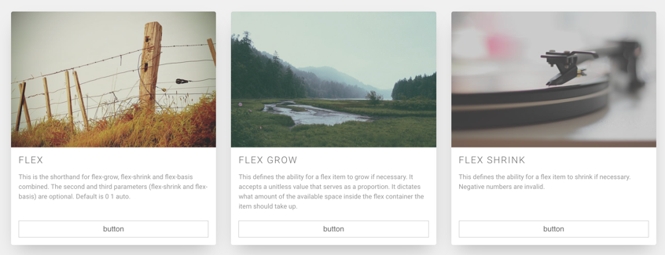

1. Let’s creat this table

Resource in “table”

